Access FlexPLM.

In the sidebar expand the season tab and in the drop down select the season you wish to add a plan for.

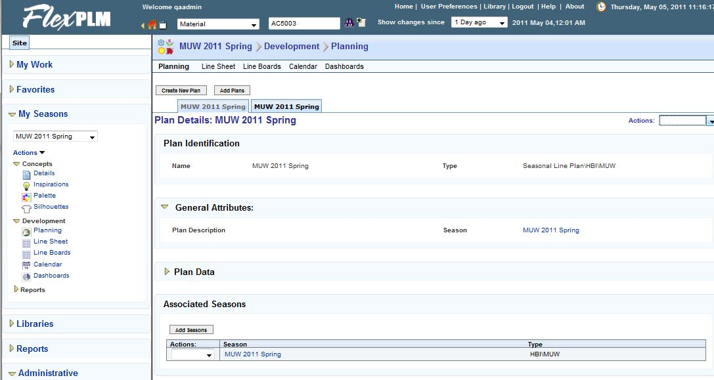

Select the planning link

In the actions menu select update plan.

Select the + block next to the plan sub group you wish to add selling styles too.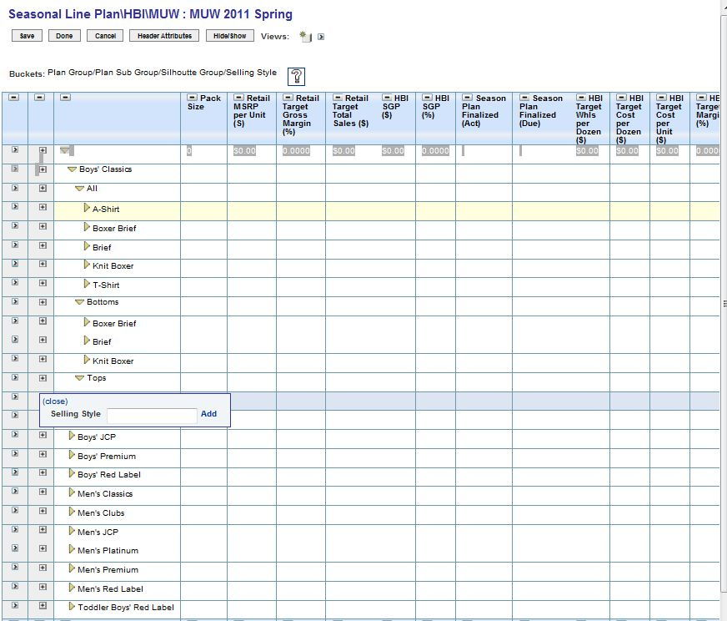

Type in the selling style you wish to plan for then select the add link

Fill out Pack size and product count.

Fill out other product financial/planning information.

Select the save button.

Select the done button.